- There was a small downside surprise for UK CPI inflation in September, as food price inflation undershot expectations. Part of this was due to greater sales and discounting, which is unlikely to be sustained, so we don't see today's data as reason to make wholesale changes to our inflation forecast. Therefore, our annual CPI forecast is unchanged at 2.8% in 2026.
- We think inflation is at its near-term peak. A smaller rise in October's energy price cap than last year should see the positive contribution from the energy category drop in next month's release. But the easing in inflation further out should be gradual, as the impact of stronger sterling and weaker wholesale prices slowly feeds through to food prices and services prices remain sticky.
CPI inflation was unchanged at 3.8% in September, an outturn that was fractionally below our forecast. Base effects meant the fuel category weighed on headline inflation less strongly, following a 0.2% m/m fall in petrol prices between September and August, compared to a 3.9% fall in the same period last year. But this was offset by a surprisingly weak outturn for food prices, with the ONS suggesting this partly reflected greater sales and discounting efforts. Elsewhere, there was also a very modest softening in core inflation. RPI inflation edged downwards by 0.1ppt to 4.5%, while RPIX inflation remained at 4.4% in September.
We think inflation is at its near-term peak. The positive contribution from the energy category should drop from October, with this year's rise in the energy price cap being much smaller than last year's increase. The impact of stronger sterling and weaker wholesale prices should start to weigh on food price inflation around the turn of the year. But the path to softer services inflation is likely to prove more gradual, as pay growth cools steadily, the impact of firms passing on this year's increase in employers' national insurance contributions slowly fades, and base effects from regulated price changes only come into play in the spring.
Though September's headline reading was slightly lower than expected, this was partly due to the temporary impact of discounting and sales in the food category, and there was little movement in the underlying drivers of inflation. So while the lower starting point from today's data has nudged down our near-term projection slightly, our 2026 CPI inflation forecast remains at 2.8%.
Chart 1: We still forecast CPI inflation to average 2.8% in 2026
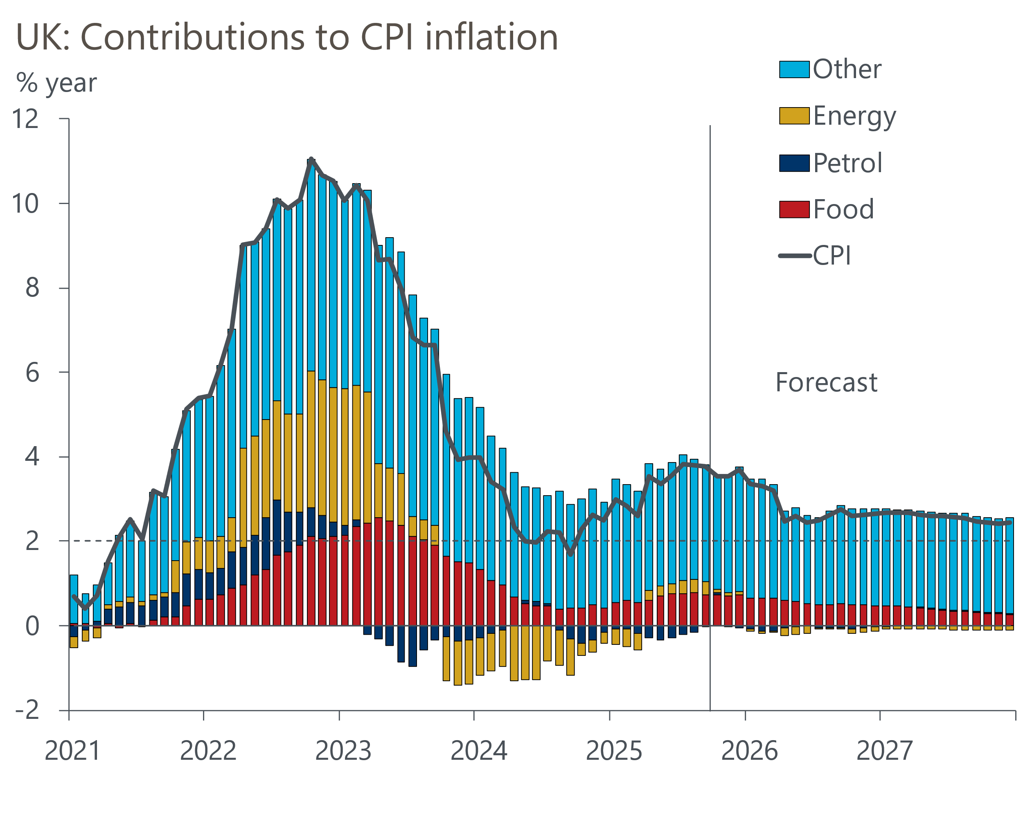
Source: Oxford Economics, Haver Analytics

